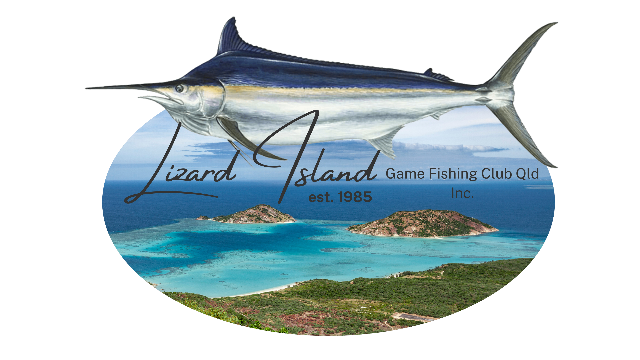

2025 Lizard Island Black Marlin Classic

**12th – 17th October 2025**

**Vessel Name**

**Vessel Make**

**Length**

**Working VHF Radio** (tick) **Skippers Name**

**Postal Address**

**Email**

**Boat Insurance Details *MANDATORY\***

**Company Policy No.**

**Mobile**

**Expiry Date**

**All onboard safety remains the responsibility of the owner/skipper**

Angler 1. M F J Club: Shirt Size:

Angler 2. M F J Club: Shirt Size:

Angler 3. M F J Club: Shirt Size:

Angler 4. M F J Club: Shirt Size:

Crew 1. M F Club: Shirt Size:

Crew 2. M F Club: Shirt Size:

Crew 3. M F Club: Shirt Size:

Crew 4. M F Club: Shirt Size:

# OPT IN TO OPTIONAL CALCUTTA POOL $2,000 PER BOAT WITH WINNER SPLIT AS PER RULES & FEES

# YES

# NO

# Late entries cannot be guaranteed a tournament pack/shirt at briefing

# All Anglers must be a member of a QGFA, GFAA or IGFA Club.

# New membership to the LIGFC is available for anglers not currently a member of a club affiliated with QGFA, GFAA or IGFA. Please indicate in the ‘club’ field above, if new membership is required. If IGFA membership is used, the Angler must be an International Resident.

# Adult Anglers 16+

**Please indicate numbers below.**

**Early Bird Adult Anglers**  **@ $825 each = $**

**Adult Anglers *after***

***1st August***

**Crew Packs**

**@ $875 each = $** **@ $550 each = $**

**Extra Shirts XS/S/M/L/XL/XXL/XXXL @ $50 each = $**

**TOTAL $**

**Post to:** The Treasurer LIGFC Qld Inc.

P.O Box 770

Maryborough, QLD 4650

# Email entry forms to [sectreas@lizardislandgamefishingclub.com.au.](mailto:sectreas@lizardislandgamefishingclub.com.au) Payment made to Club Bank Account Details: BSB 084-970 Account 10-288-1777 National Australia Bank

We agree to the rules as published. In consideration of your accepting me/us as a competitor or guest (as the case may be), I/we absolve the Lizard Island Game Fishing Club Qld Inc., its committee, officers, members and sponsors as such from any liability whatsoever arising and occurring or resulting from the tournament, and I/we hereby indemnify you and agree to keep you indemnified against all claims, damages, costs and loss that may be claimed or awarded against you, or that you may suffer resulting from injury or loss to me/us or any of my/our invited invitees or licensees or guests or to any property of my/our invitees, licensees or guests

**Signed (Team Captain) Name** **Signature Date**